ROUND 1
QUES 1 - Who is this team, and why is this opening yours?
Answer 01
One line per member

Vibhuti Gupta: Most of the things ordered by me come from my family, and my mother always handles the OTP part for us.
Meghna Kumari: In my wing of the hostel I usually end up collecting all the parcels of other people when they are studying.
Aviral Awasthi: For three consecutive days my pickup got missed because I could not receive calls from the courier.
As a team (50 words)

All of us stay in the hostels of IIT Patna Bihta, where there is only one gate entry point, and the guard maintains a register. In this week's survey we interviewed six people including 30 students, two hostelers, one parent left outside the gate, and one delivery executive calling OTPs.
QUES 2 - 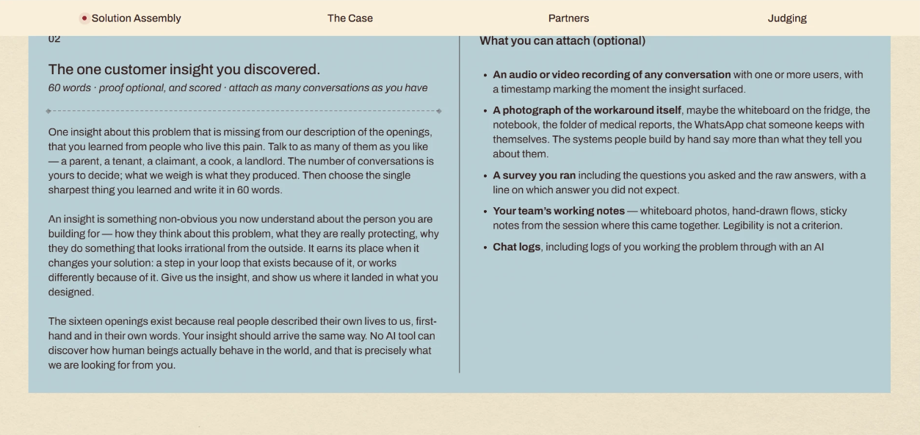
ANSWER 2
People are already handing over their OTP to whosoever is at home. They hate the fact that the code, once handed over, can't be retracted. The cynics did not accept the auto-OTP system for this reason. "It should always be in my control," was what they had mentioned. Thus, we got rid of the common code. Now, the trusted members approve from their phone, and the owner can revoke them anytime.

"The answer you did not expect" (for the survey attachment)

We expected the receiver to be a family member or hostel staff. However, 40% of our respondents admitted to receiving the package from a roommate or friend, while 33% finally picked up the package themselves. The actual receiver is someone on the same level in a hostel environment. Hence, the trusted circle revolves around vouched wingmates rather than a nominated family member.
QUES 3 -
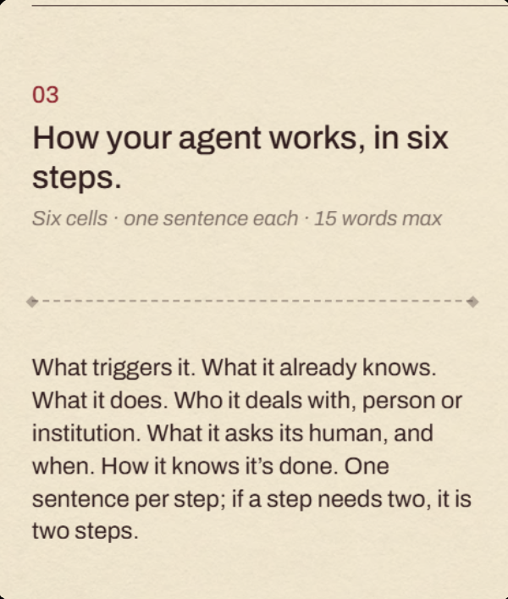
Answer 03
1. What causes it
A package is sent out to a residence which is known to have a trusted circle.

2. What it knows
It knows who these members are, the private key of their phones, and the geofence of their house.

3. What it does
It sends a parcel specific authorization for the package, without an OTP and reaches out to all the members.

4. Who it interacts with
It interacts with the delivery agent and the member who unlocks the door.

5. What it asks its human and when
It will reach out to the owner if none of the members press the button for approval or rescheduling of the delivery.

6. How it knows it has finished
The button press of the member signifies the end of the delivery along with the delivery confirmation log.
QUES 4 -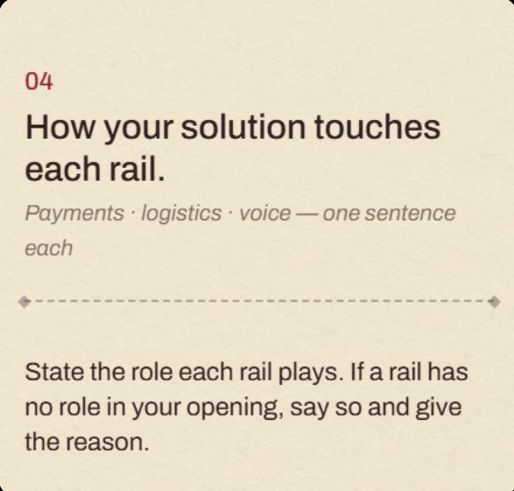

ANSWER 04

Payments and Authorizations: This solution provides the trusted circle, replaces the OTP with one time per parcel authorization, validates the phone signature of the member and maintains the proof log and instantaneous revoking facility.

Logistics: The courier application will transport the parcel, removes the OTP field, enables the handover only when the geofencing is activated for the address, displays the name of the receiver, and conducts returns through the same credentials.

Voice: When no one is responding, it will call the owner first and thereafter the rest of the members via the masked telephone line in their respective languages.
QUES 5 -
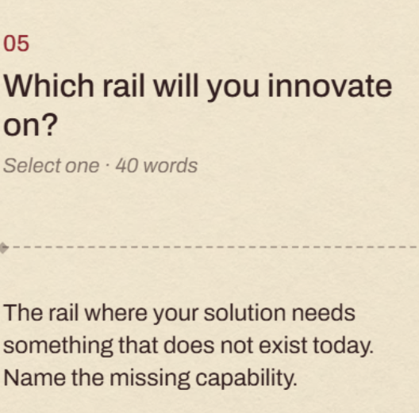
ANSWER 05

Payments and authorisation. Currently the delivery OTP can be linked to only one account holder’s phone. We need an authorisation that a circle already pre enrolled can fulfill: any of them can approve on their own device, the owner can revoke anyone instantaneously, and every transfer is signed.
QUES 6 -
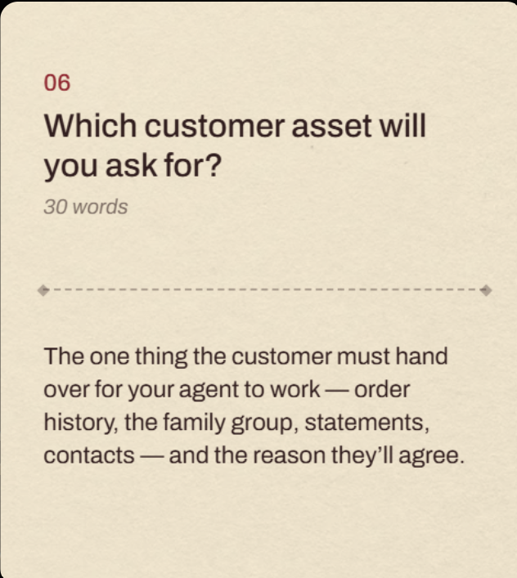
Answer 06

I’d ask for their trusted circle—the names and numbers of people they’re comfortable having receive parcels. They already trust these people with OTPs, making one-time deliveries easier.

QUES 7-
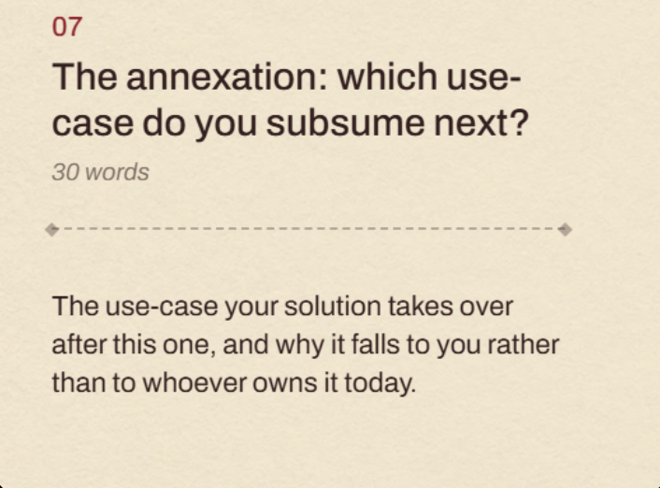

ANSWER 7-
Returns and exchange pickups. Once a household's trust circle exists, we're the only party who can authorise a courier to collect without re-verifying identity from scratch — everyone else still needs a new booking flow

QUES 8-
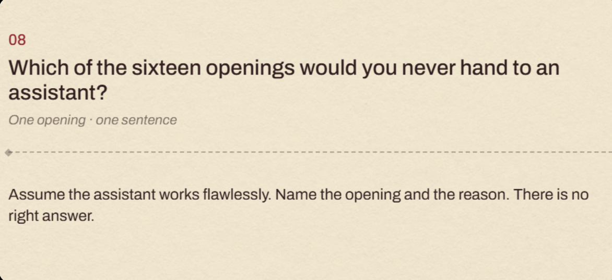

ANSWER 8-
What do I cook today," because it hinges on a craving the cook only feels in that moment and the choosing is itself a small daily act of care, so even a flawless pre made menu is still the wrong meal.
QUES 9-
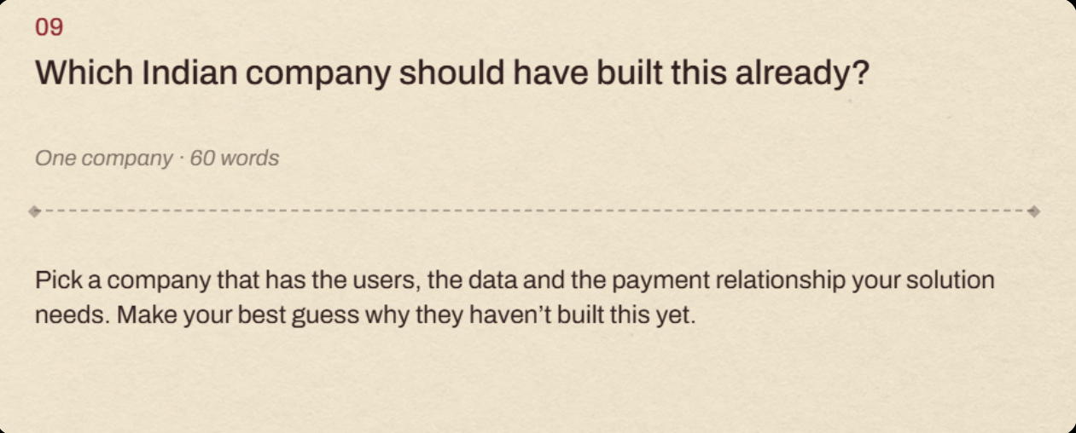
ANSWER 9
Flipkart. It owns Ekart end to end, the order and address history, and the payment relationship through Flipkart UPI. It has not built this because the OTP belongs to fraud and RTO risk teams, not customer experience, so nobody owns cutting courier calls, and a household identity weakens the one account per customer model its ads and recommendations depend on.

QUES 10-
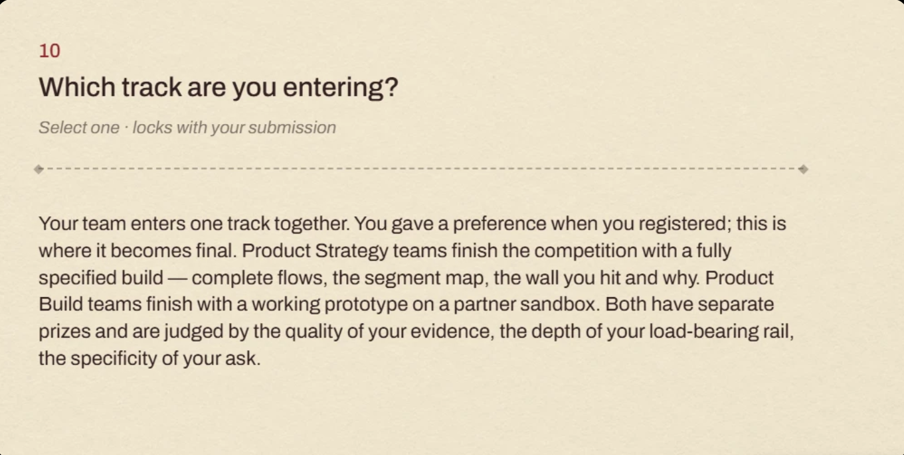
Answer 10

Product Strategy

This track fits what we’ve already done. We have a 30-response survey, six recorded conversations covering four hostel residents, a parent at the door, and a delivery agent, along with a photo documenting the workaround people currently use.

The main insight is that the problem comes down to a missing primitive: a group-level authorization that any member of the circle can approve from their own phone, with the ability to revoke it instantly and a clear record of who authorized it.

Our ask is fairly specific: a new object for Pine Labs on P3P, one change to the courier app for Delhivery, and a masked escalation fallback for Gnani.

The main barrier isn’t building the technology. It’s that this authorization mechanism doesn’t exist today, while OTPs are tied closely to fraud and risk systems that have little incentive to change. That’s where a product strategy approach matters more than simply building a sandbox prototype.

ROUND 2

QUES 01- 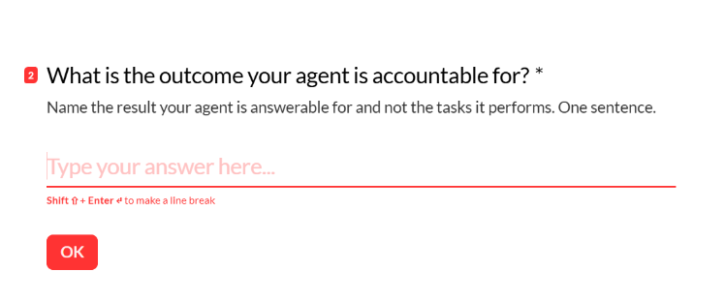
ANSWER 1
The agent is accountable for every parcel reaching a person the buyer actually authorised, interrupting the buyer only when nobody in their trusted circle responds
QUES 2-
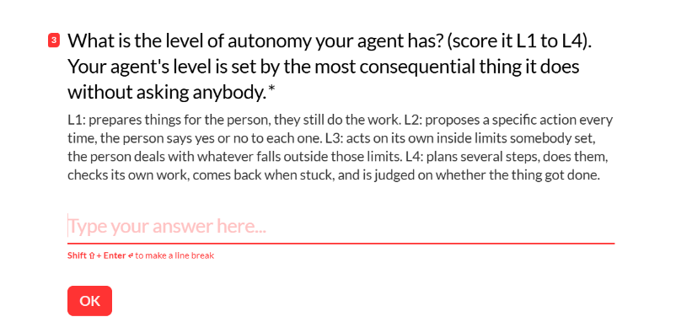
ANSWER 2-
L3. The most consequential thing the agent does without asking anybody is releasing a parcel worth real money to a person at the door, cleared by a signed approval from their own device inside a trusted circle the buyer defined in advance, a capability we build on the payments rail. That happens autonomously, every delivery, with no human decision at the moment it occurs, unlike an agent that has to ask for approval on each one. The moment nobody in the circle taps, the agent does not decide on its own to hand the parcel over anyway. It calls the buyer through Gnani's Trigger Call, escalating to other circle members in turn if they don't answer; whoever picks up chooses between an immediate OTP for the person at the door or a reschedule, and the agent only picks a default itself, always a reschedule through Delhivery's NDR API, never the OTP, if the entire call chain goes unanswered. That handoff of judgment back to a human for anything but the safest fallback is what keeps it at L3 rather than L4.

QUES 3-
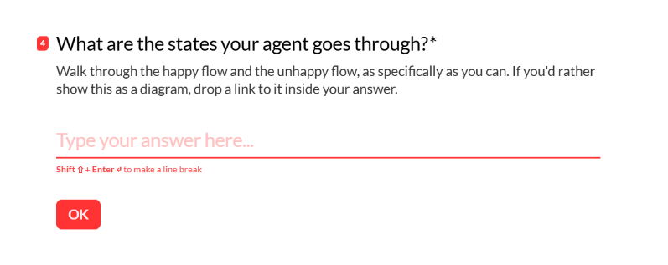
ANSWER 3
Happy flow: Enrolled, the buyer's circle is live with signing keys issued to each member's phone. Dispatched, the parcel leaves the hub and a one time grant token is issued for it. Notified, every circle phone gets a heads up before the courier arrives. Awaiting handoff, the courier is at the door and has requested it. Approved, a present circle member taps or scans, their device signs it, the signature is verified against the token. Delivered, the parcel is handed over, the signature, timestamp, GPS and photo are logged as proof. Closed, the buyer gets a push notification naming who received it and when.

Unhappy flow, every branch and what the agent does about it: Nobody taps inside the window. The agent calls the buyer first through Gnani's Trigger Call. If the buyer answers, they choose OTP now for the person at the door or reschedule, and the agent carries out whichever they pick. If the buyer does not answer, the agent escalates to the other circle members in turn through a masked number, and whoever answers gets the same two choices. If the entire chain goes unanswered, the agent defaults on its own to reschedule through Delhivery's NDR API, never to the OTP, since releasing a parcel without an actual human choice is the one thing it is never allowed to decide alone. A signature does not match an enrolled device. The handoff is rejected on the spot, the parcel is held, and the courier's next attempt re-enters the same window, ending in the call chain above if it fails again. The owner revokes a member while their approval is still pending. That grant dies immediately, the tap already in progress fails as an invalid signature, and it is treated exactly like the case above.

QUES 4-
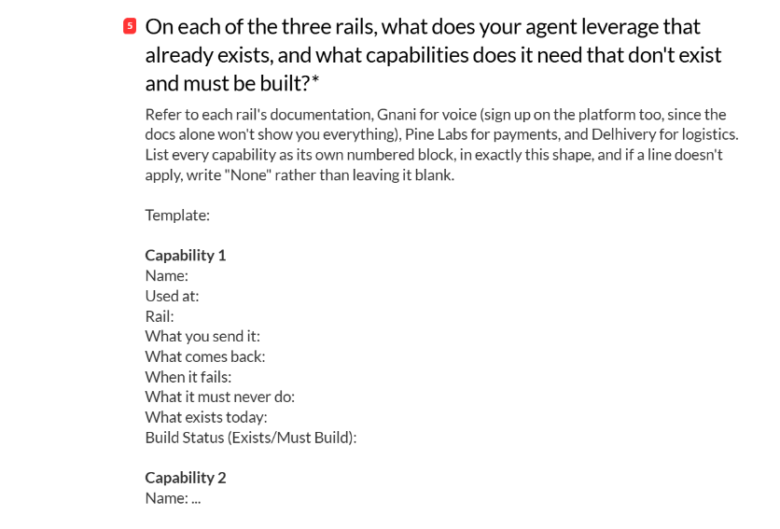
ANSWER 4
Payments and authorisation
Capability 1
Name: issue_household_grant
Used at: Dispatched
Rail: Payments and authorisation
What you send it: circle_id, parcel_id, address
What comes back: a scoped, one time grant_token tied to that parcel
When it fails: the address has no enrolled circle, it says so and stops, no token issued
What it must never do: issue a grant when there is no live enrolled circle behind that address
What exists today: Setu's (Pine Labs group) AA Gateway already issues scoped, revocable, purpose bound consent, approved through an embeddable screen, built for one user approving one request, not a group where any of several people can discharge it
Build Status (Exists/Must Build): Must Build
Capability 2
Name: verify_member_approval
Used at: Approved
Rail: Payments and authorisation
What you send it: the member's device signature, the grant_token
What comes back: valid or invalid, plus which enrolled member signed
When it fails: the signature does not match an enrolled device, rejected and logged
What it must never do: accept an approval from a device that is not enrolled in that household's circle
What exists today: Setu's Aadhaar eSign gives a legally valid per person signature, and AA's approve or reject screen is the right interaction, neither recognises "any one of several enrolled people" as a valid approver for one request
Build Status (Exists/Must Build): Must Build
Capability 3
Name: revoke_member
Used at: Any time, owner triggered
Rail: Payments and authorisation
What you send it: member_id
What comes back: a revoked confirmation, kills any pending grant tied to that member immediately
When it fails: the member_id given does not belong to this household's circle, rejected with no state change
What it must never do: silently ignore a revoke request, or let a pending grant for a removed member still clear
What exists today: the AA framework treats consent withdrawal as a first class, user initiated action at any time, that exact behaviour, just not scoped to a household member list
Build Status (Exists/Must Build): Must Build

Logistics
Capability 4
Name: request_handoff
Used at: Courier at the door
Rail: Logistics
What you send it: parcel_id, courier device id
What comes back: the current grant status, pending or approved
When it fails: no grant exists yet or it is still pending, the parcel is held
What it must never do: release the parcel on Delhivery's own OTP once a household has Ghar Pass enrolled
What exists today: Delhivery's webhook fires in real time at every status change including Dispatched, and additional payload fields can be mapped in on request, but this is a one way status broadcast, not a synchronous gate a third party can use to approve or deny a release before it happens
Build Status (Exists/Must Build): Must Build
Capability 5
Name: confirm_geofence
Used at: Approved
Rail: Logistics
What you send it: the courier's current coordinates
What comes back: whether the courier is inside or outside the delivery address's geofence
When it fails: outside the geofence, the release is blocked
What it must never do: trust a single GPS ping without a distance check against the verified address
What exists today: Delhivery Maps has real, documented Geocoding, Reverse Geocoding, Address Validation, Address Verification, and Routing APIs, no dedicated geofence check endpoint and no live GPS feed exist
Build Status (Exists/Must Build): Must Build
Capability 6
Name: book_return_pickup
Used at: Return requested
Rail: Logistics
What you send it: parcel_id, grant_token
What comes back: a scheduled pickup slot
When it fails: the shipment is not eligible for reverse pickup, it says so
What it must never do: None
What exists today: Delhivery's Reverse Pickups API is real, and RVP QC 3.0 already runs a mapped set of mandatory questions with required photos at the doorstep, the pickup only proceeds if answered correctly, the exact shape our returns check needs
Build Status (Exists/Must Build): Exists
Capability 7
Name: trigger_reschedule
Used at: The call chain goes unanswered, or a human on the call chooses reschedule
Rail: Logistics
What you send it: waybill, action (RE-ATTEMPT or PICKUP_RESCHEDULE)
What comes back: a request ID to poll for status
When it fails: the attempt count is already at the limit, or the shipment's status does not allow that action, rejected
What it must never do: reschedule a shipment that was never actually approached by a courier
What exists today: Delhivery's NDR API, a real, live, production endpoint
Build Status (Exists/Must Build): Exists

Voice
Capability 8
Name: call_owner
Used at: No member taps in the window, tried first before any other circle member
Rail: Voice
What you send it: the buyer's number, countryCode, a clientReferenceId, a system prompt
What comes back: callStatus (answered or no answer), a disposition code, an LLM call summary, and the full transcript
When it fails: callStatus is no answer, escalation moves on to the other circle members in turn, a separate step that only starts once the owner specifically has been tried and missed
What it must never do: skip straight to a circle member before the owner has been attempted, even if a member's number is already known
What exists today: confirmed via Gnani's Trigger Call endpoint on their Platform API, language switching and DTMF are documented, named features
Build Status (Exists/Must Build): Exists
Capability 9
Name: call_masked_member
Used at: Owner unreachable, escalating through the circle after the owner specifically has already been tried
Rail: Voice
What you send it: a member_id, never the real phone number
What comes back: call outcome, same fields as call_owner
When it fails: no answer, escalates to the next member in the circle
What it must never do: expose a real phone number to the courier or in any call log beyond what is needed
What exists today: nothing, Gnani's Trigger Call request schema takes the destination phone as a plain field, no masking or proxy option documented anywhere
Build Status (Exists/Must Build): Must Build
QUES 5-
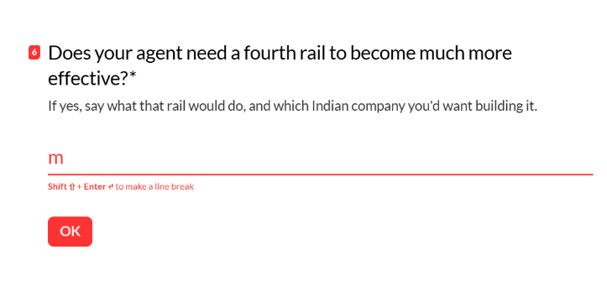
ANSWER 5
No. Three rails are enough. Payments and authorisation carries the household grant, logistics carries the handoff and returns, voice carries the fallback, and each already has a Must Build capability that closes its real gap. A fourth rail here would trade convenience for a kind of certainty nobody asked for, and our own research never surfaced a need for it. The existing safeguards, owner controlled enrolment, instant revoke, and a signed proof log naming who received each parcel, are the right amount of protection for something at the stakes of a parcel, not a bank transaction.
QUESTION 6
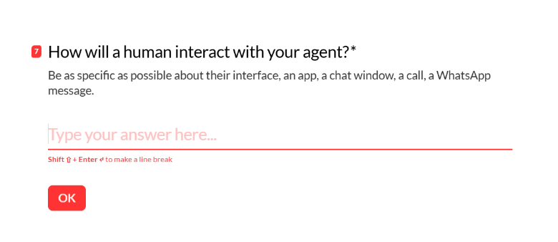
ANSWER 6
Buyer: the existing shopping app. One settings screen to add or remove people from the trusted circle. Per delivery, a push notification, "Delivery now, tap to receive," if they're the one home. If nobody taps and the call chain reaches them, a phone call from Gnani's Trigger Call, spoken conversation or a DTMF press, 1 for OTP now, 2 for reschedule. After the parcel is handed over, a push notification confirming who received it and when.
Circle members: the same app if they have it installed, or a one time consent link sent by SMS or WhatsApp to enrol if they don't. Per delivery, the identical push notification and tap. If their phone has no data at that moment, the courier's app shows a QR code for that parcel, and they scan it instead of tapping. If the call chain escalates to them, the same call from Gnani with the same two choices as the buyer gets, OTP now or reschedule, not a different flow. They can remove themselves from the circle in the same settings screen, no owner approval needed.
Delivery agent: their existing Delhivery app, unchanged except for one thing. The OTP entry field is replaced by a "request handoff" button and a status line that reads pending, then verified with the receiving member's name once someone taps or scans. No new app, no call-household button, the escalation runs entirely on our backend through Gnani, the courier never initiates or sees any of it.
QUESTION 7
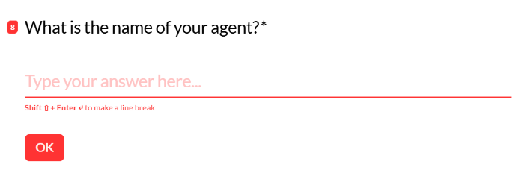
ANSWER 7
Ghar Pass
QUES 8-
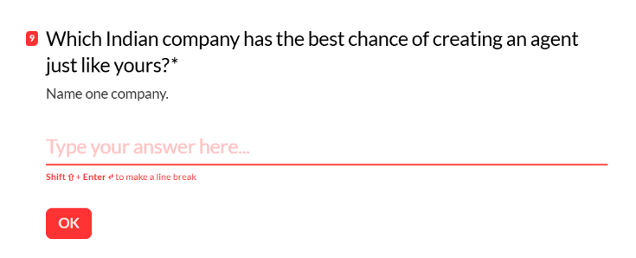
ANSWER 8
Flipkart

